Information System Security

Introduction to the security of ICT systems
Complexity is an enemy of security, the more complex a system is, the more difficult its correctness verification will be.

A definition of ICT security
It is the set of products, services, organization rules and individual behaviors that protect the ICT system of a company.
“Products”, is something that you buy. Those products are used to implement securities services. You must give also organization rule.
It has the duty to protect the resources from undesidered access, guarantee the privacy of information, ensure the service operation and availability in case of unpredictable events. This three points are the C.I.A. = Confidentiality, Integrity, Availability.
The objective is to guard the information with the same professionalism and attention as for the jewles and deposit certificates stored in a bank caveau.
The ICT system is the safe of our most valuable information (REGSTR)

Risk estimation
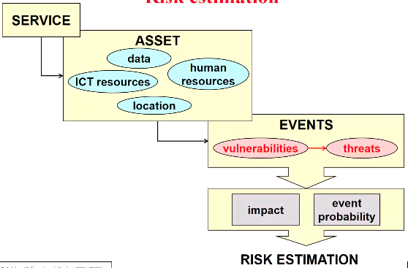
We need to approach it in a structured way. We have to understand the risk, in order to estimate them we have to start from the server. Then we have to identify the assets, there are the four categories in the image:
- data: something intangible, protect them is important and is different from protecting where they are stored;
- location: if your assets are inside a protected room ok, but
- human resources: there are some persons that
…
We have to decide for each threat which impact it can have. Finally we get a risk estimation.

Terms
From the slide

Analysus and management of security
The analysys part is composed by three aspects: assets, vulnerability and threats. This three things gives us a list of risks.
Manage the security means: for the risk not acceptable, you need to select countermeasures. Then you need to implement them and then to audit, that means that some independent person is checking your work.
…
Some security principles:
- security in depth: you have a list of defends;
- security by design: security must be designed along with the system;
- security by default: the user should not have a choice to activate security or not;
- least privilege: any element that operates in the system should be assigned with the least privilege he need to operate;
- need-to-know: you should give to any component of the system only to

European Central Bank is an example

